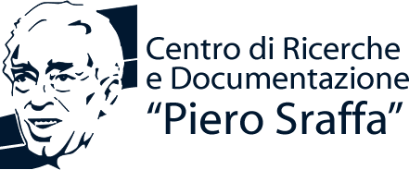
School of Advanced Studies in the Reappraisal of the Surplus Approach
APPLICATION FORM
To be sent to cssummerschool2018@gmail.com together with a brief curriculum vitae
Surname |  | First Name

Date of Birth |  | Nationality

Sex | M |  | F | E-mail

Academic background:
University degree awarded on (month/year)

Title of the thesis

University

Thesis supervisor

PhD Student
University

PhD thesis supervisor

Topic of the thesis

Postdoctoral fellow
University (current affiliation)

PhD awarded on (month/year)

PhD thesis supervisor

Title of the PhD thesis

University
Candidature for young scholars’ presentations:
I wish to present a contribution in the young scholars’ session of the School and I will therefore send an abstract of my paper (600-1000 words) by May 15th, 2018
Candidature for the Scholarship:
Being unable to support my participation with institutional or other financing sources, I wish to be considered for the grant of Centro Sraffa

