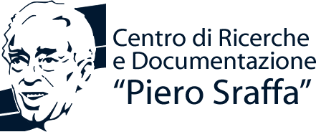
School of Advanced Studies in the Reappraisal of the Surplus Approach
APPLICATION FORM
Please name this file “YourSurname_AF” and sent it to cssummerschool2019@gmail.com together with a brief curriculum vitae named “YourSurname_CV”
Surname |  | First Name

Date of Birth |  | Nationality

Sex |  | E-mail

University degree awarded on (month/year)

Title of the thesis

University

Thesis supervisor

Please fill this box only if you are currently a PhD Student:
University

PhD thesis supervisor

Topic of the thesis

Please fill this box only if you are currently a Postdoctoral fellow:
University (current affiliation)

PhD awarded on (month/year)

PhD thesis supervisor

Title of the PhD thesis

University
Candidature for young scholars’ presentations:
Do you wish to present a contribution in the young scholars’ session of the School?
If so, please remember to send an abstract of your paper (500-900 words) by May 8th.
Candidature for the Scholarship (for applicants unable to support their participation with institutional or other financing sources):
Do you wish to be considered for the grant of Centro Sraffa?
If so, please also send a cover letter in a separate file named “YourSurname_CL”.

If you are an undergraduate student, please indicate when do you expect to obtain your degree.

